Alcohol Thermometer
# Source: AI Source: Provided by: [Data Path: Persons Table -> ID Column: 1, Name_En Column: Motasem Essam] -> From: [ChatGPT] on [7/17/2026]
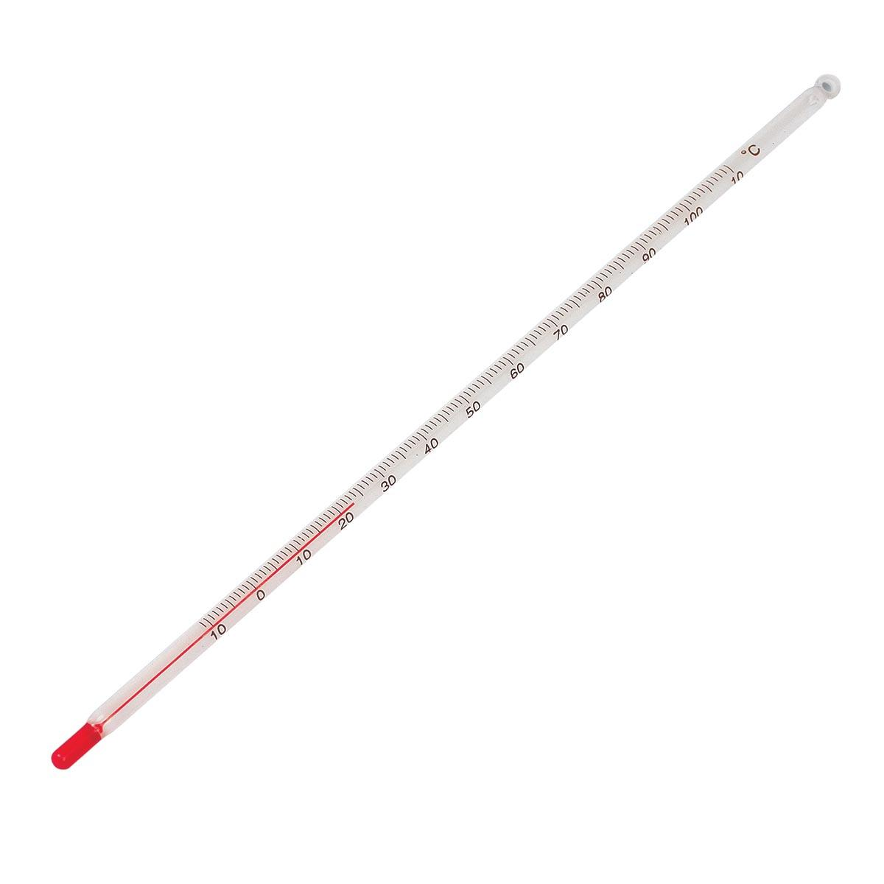
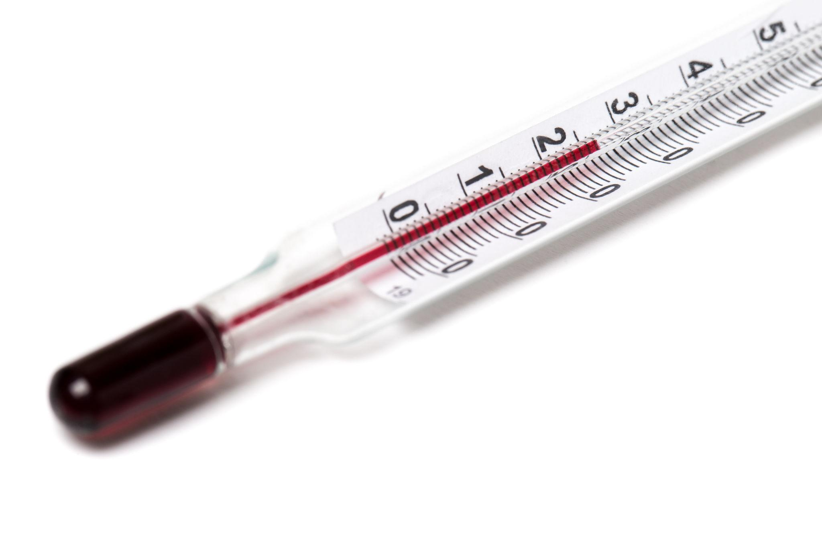
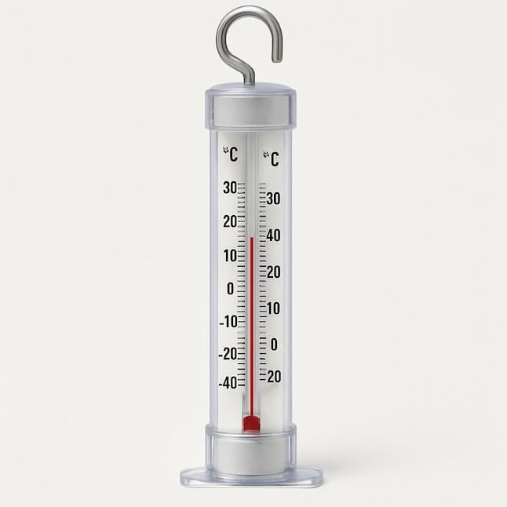
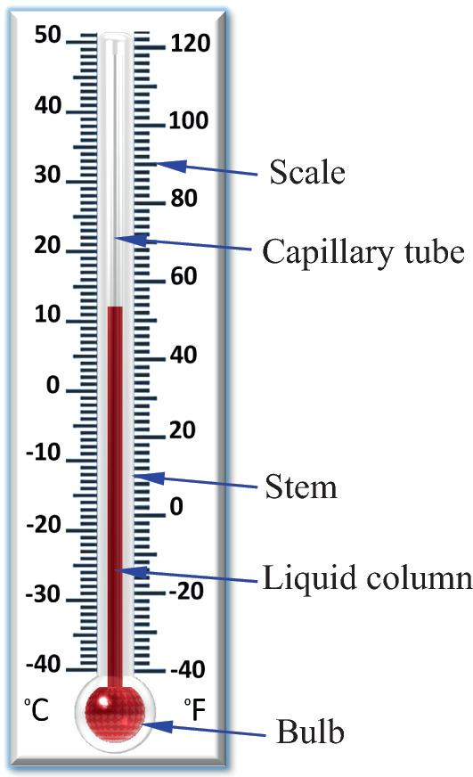
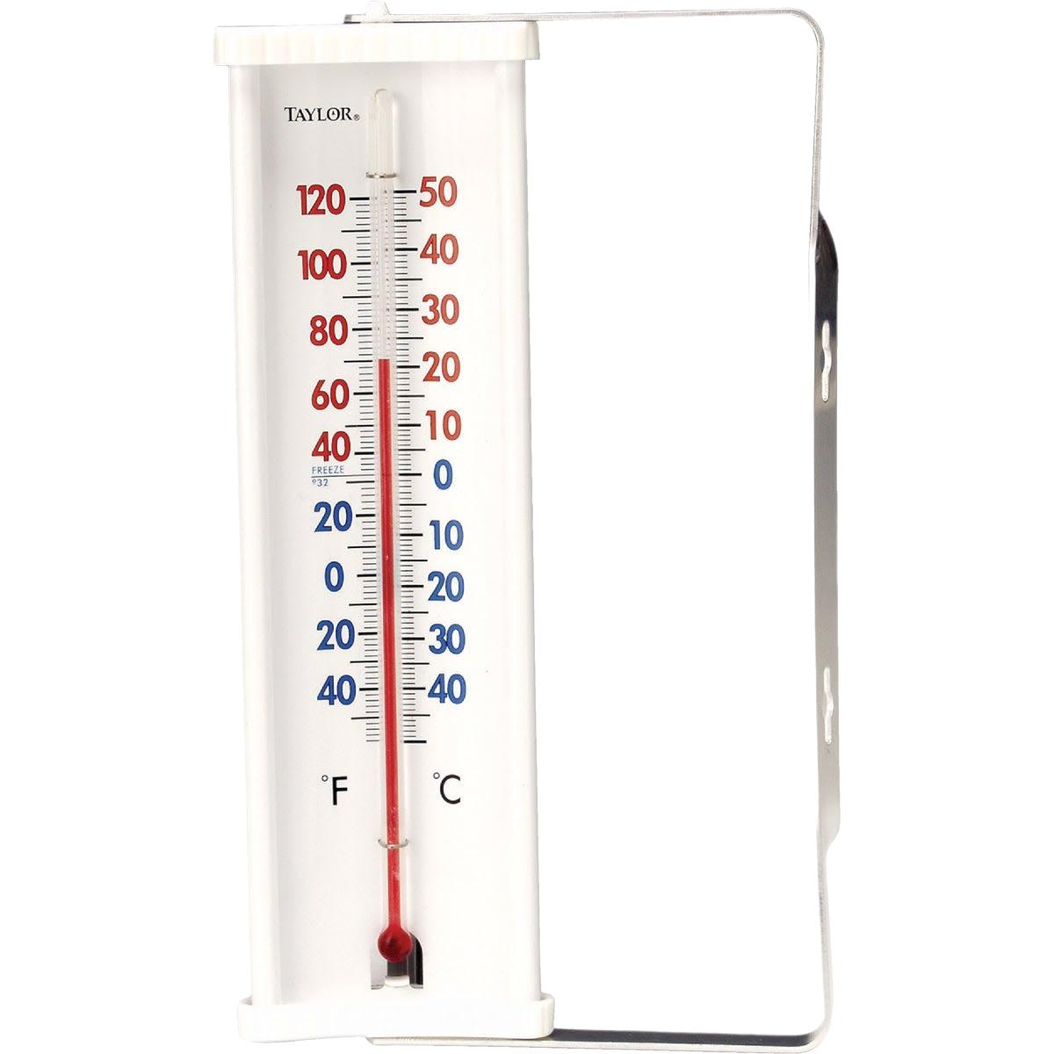
An Alcohol Thermometer (also called a Spirit Thermometer) is a liquid-in-glass temperature-measuring instrument that uses colored alcohol (typically ethanol, toluene, or another suitable organic liquid) instead of mercury. As the temperature changes, the alcohol expands or contracts inside a sealed glass capillary tube, causing the colored liquid column to rise or fall.
Alcohol thermometers are widely used in meteorology, education, laboratories, refrigeration, environmental monitoring, and low-temperature measurements because they are safer than mercury thermometers and can measure temperatures well below the freezing point of mercury.

Definition
# Source: AI Source: Provided by: [Data Path: Persons Table -> ID Column: 1, Name_En Column: Motasem Essam] -> From: [ChatGPT] on [7/17/2026]
An Alcohol Thermometer is a liquid-in-glass thermometer that measures temperature by the thermal expansion and contraction of colored alcohol inside a sealed glass capillary tube.

Purpose
# Source: AI Source: Provided by: [Data Path: Persons Table -> ID Column: 1, Name_En Column: Motasem Essam] -> From: [ChatGPT] on [7/17/2026]
An alcohol thermometer is used to:
- Measure air temperature.
- Measure liquid temperature.
- Monitor laboratory experiments.
- Measure low temperatures.
- Record environmental conditions.
- Monitor refrigerators and freezers.
- Educational demonstrations.

Principle of Operation
# Source: AI Source: Provided by: [Data Path: Persons Table -> ID Column: 1, Name_En Column: Motasem Essam] -> From: [ChatGPT] on [7/17/2026]
Alcohol expands when heated and contracts when cooled.
- Higher temperature → alcohol expands → liquid column rises.
- Lower temperature → alcohol contracts → liquid column falls.
The height of the colored alcohol column is read against a calibrated temperature scale.

Main Components
# Source: AI Source: Provided by: [Data Path: Persons Table -> ID Column: 1, Name_En Column: Motasem Essam] -> From: [ChatGPT] on [7/17/2026]

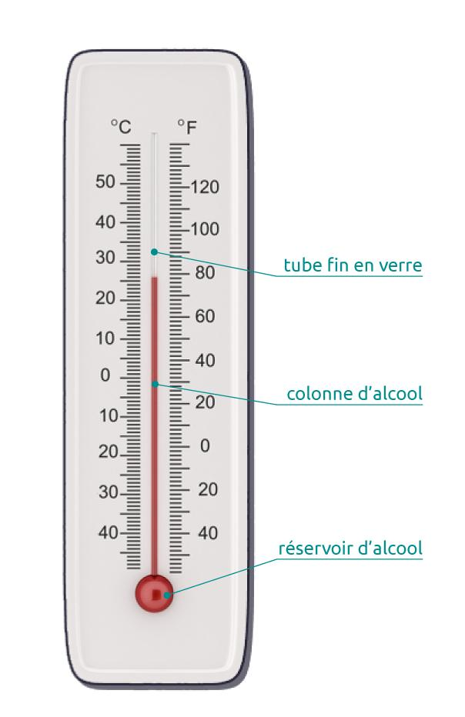
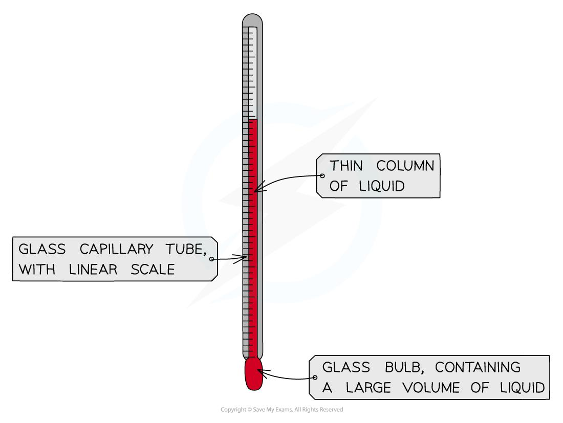
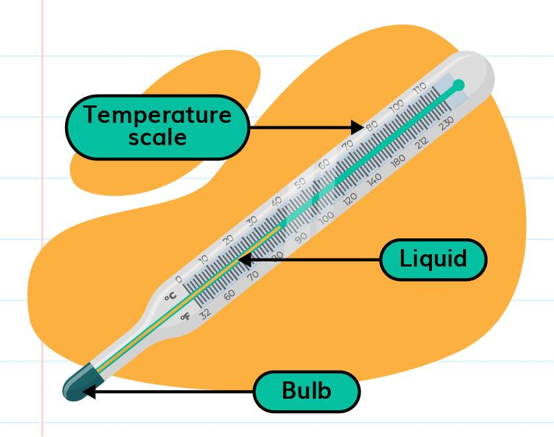
A typical alcohol thermometer consists of:
- Alcohol reservoir (bulb)
- Colored alcohol
- Glass capillary tube
- Graduated temperature scale
- Glass stem
- Expansion chamber (in many laboratory models)

Types of Alcohol Thermometers

1. Laboratory Alcohol Thermometer
# Source: AI Source: Provided by: [Data Path: Persons Table -> ID Column: 1, Name_En Column: Motasem Essam] -> From: [ChatGPT] on [7/17/2026]

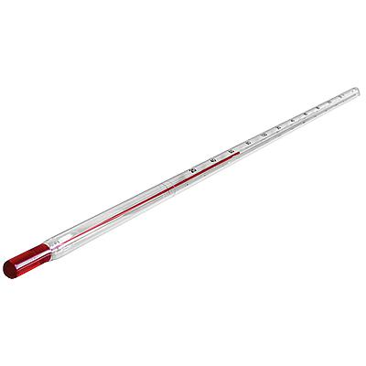
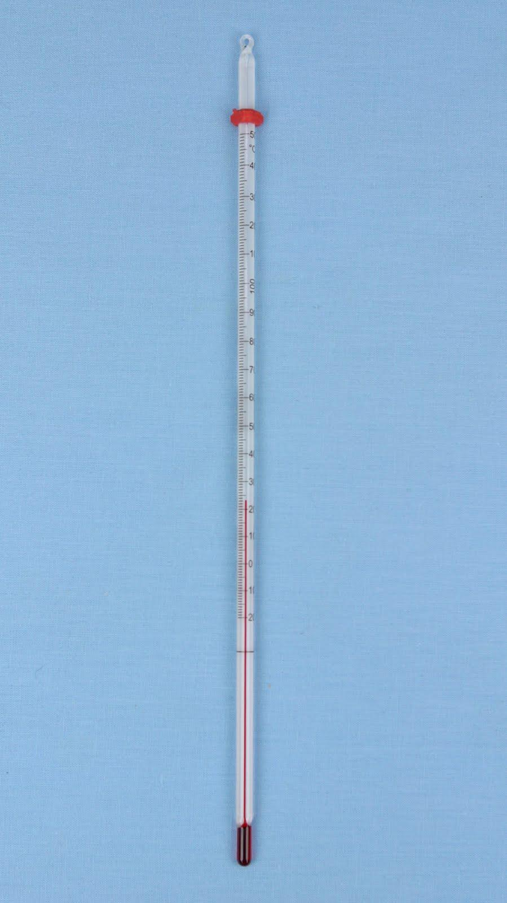
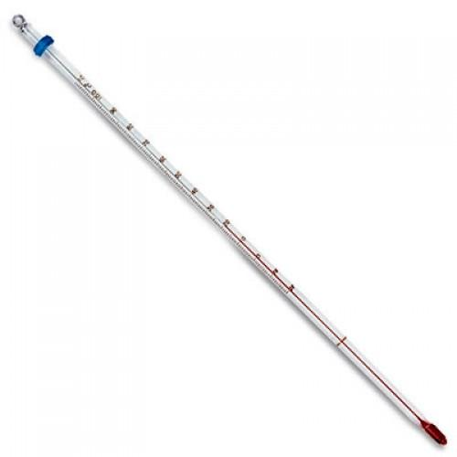
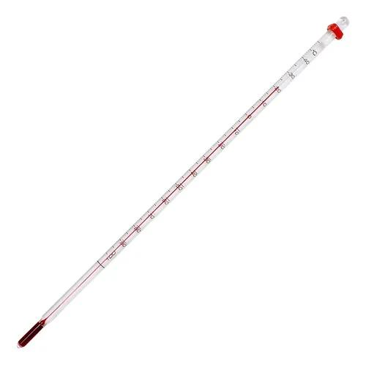
Description
Designed for scientific and educational measurements.
Features
- Wide measuring range
- Colored liquid for easy reading
- Good low-temperature performance
Applications
- Chemistry
- Biology
- Schools
- Universities

2. Weather (Meteorological) Alcohol Thermometer
# Source: AI Source: Provided by: [Data Path: Persons Table -> ID Column: 1, Name_En Column: Motasem Essam] -> From: [ChatGPT] on [7/17/2026]
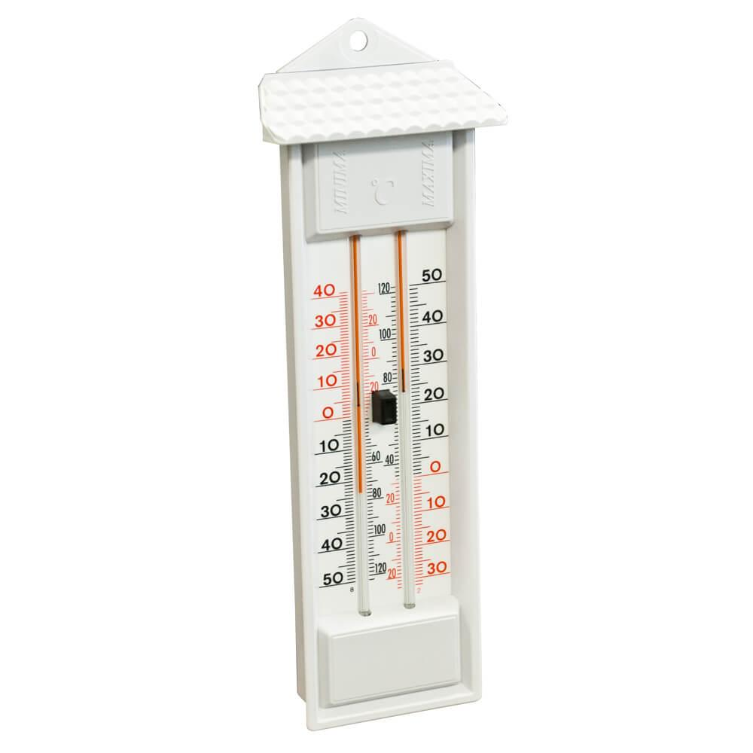
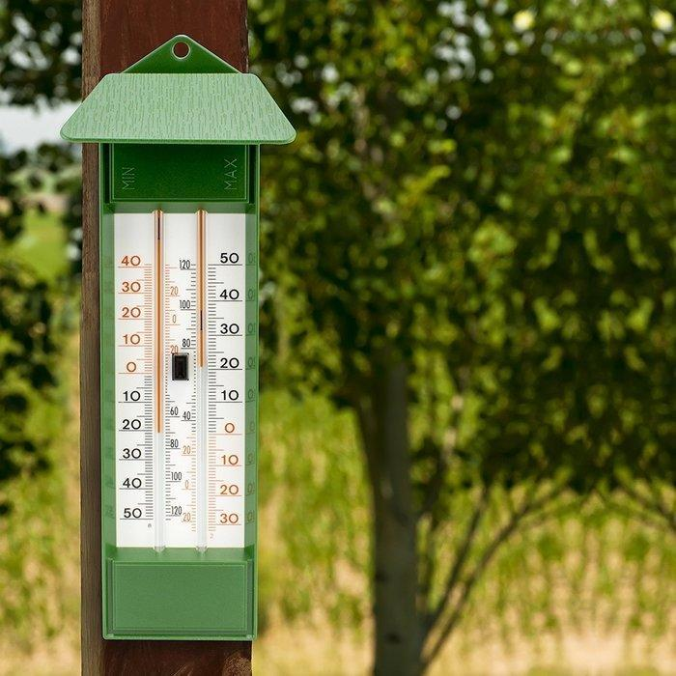
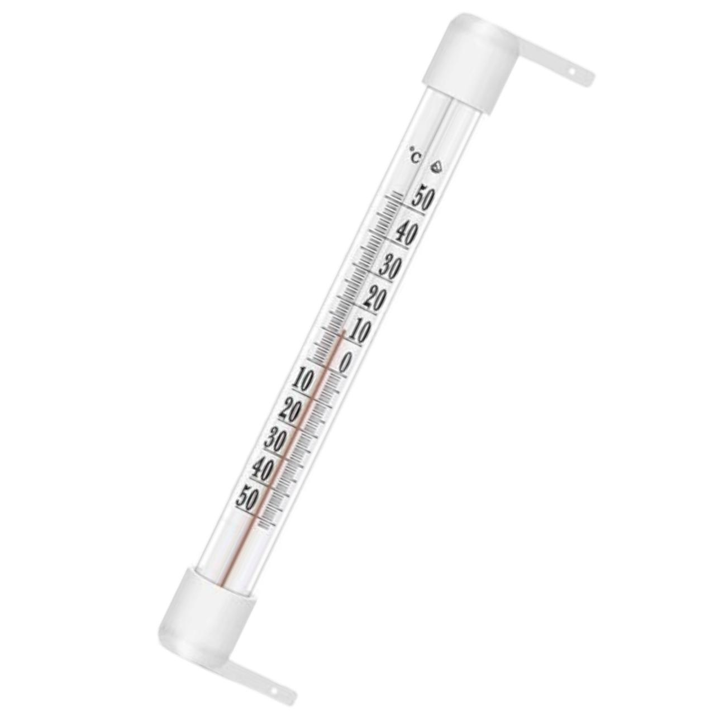
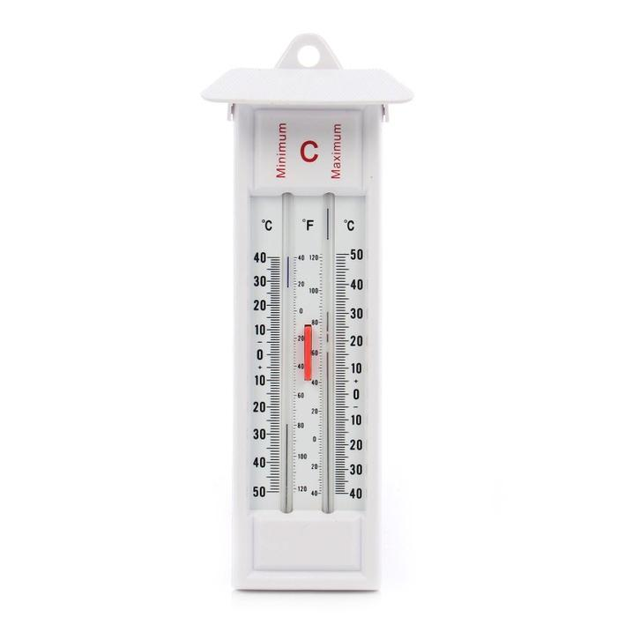
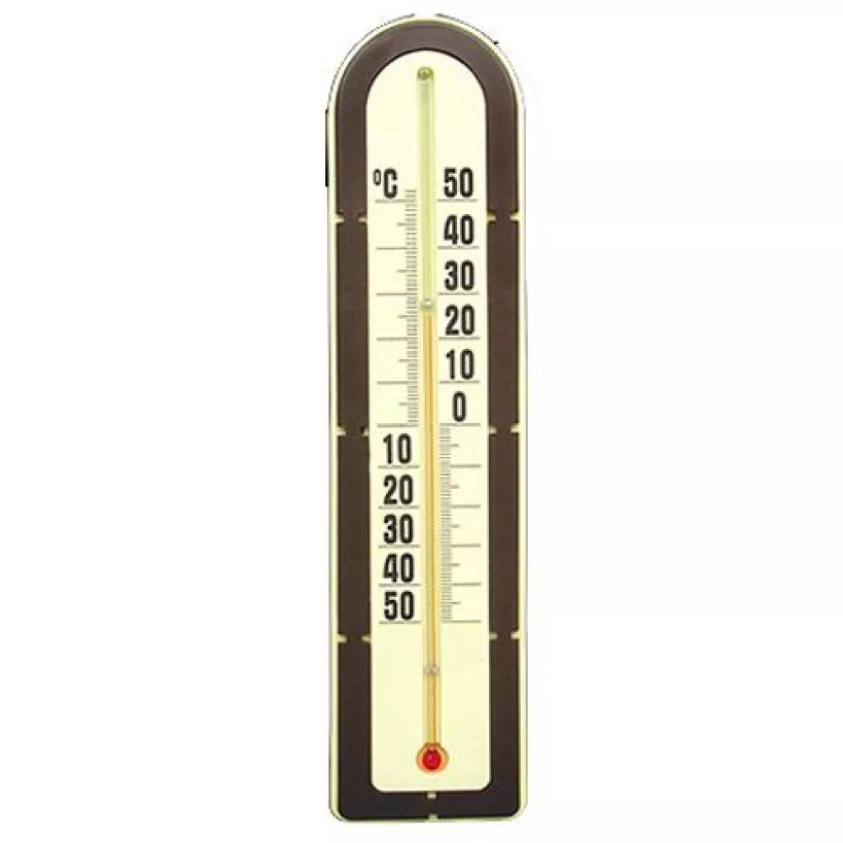
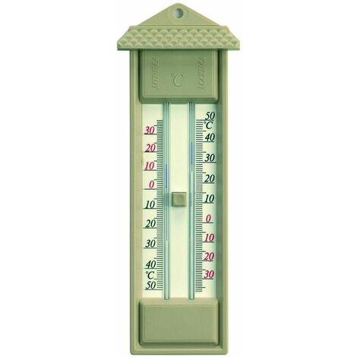

Description
Used for measuring outdoor air temperature.
Applications
- Weather stations
- Agriculture
- Environmental monitoring

3. Refrigerator / Freezer Alcohol Thermometer
# Source: AI Source: Provided by: [Data Path: Persons Table -> ID Column: 1, Name_En Column: Motasem Essam] -> From: [ChatGPT] on [7/17/2026]
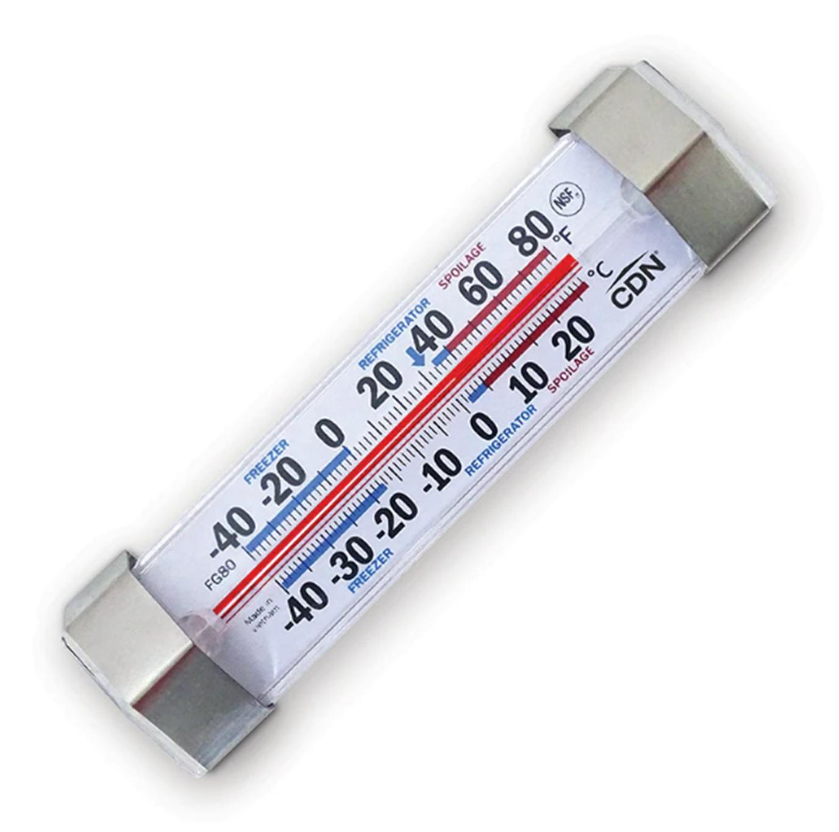
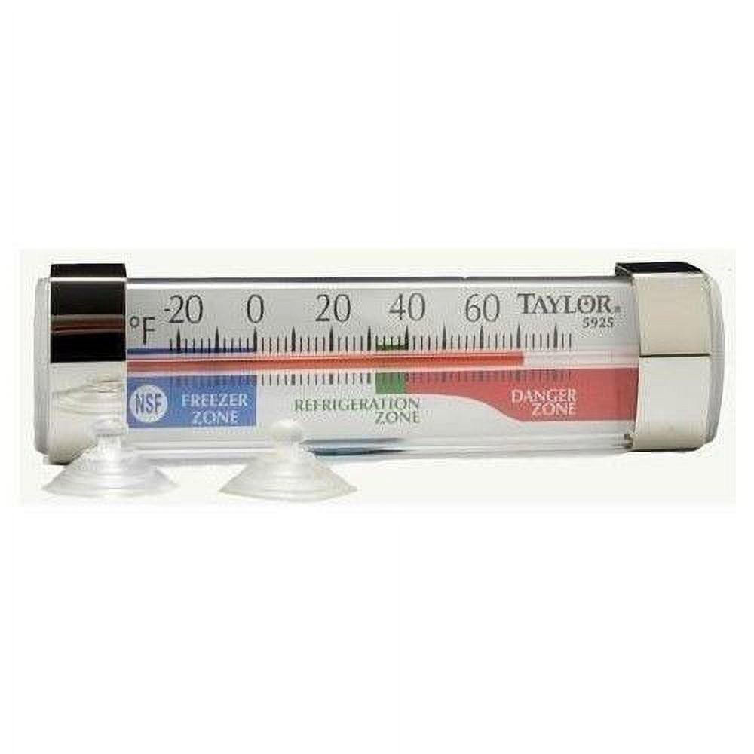
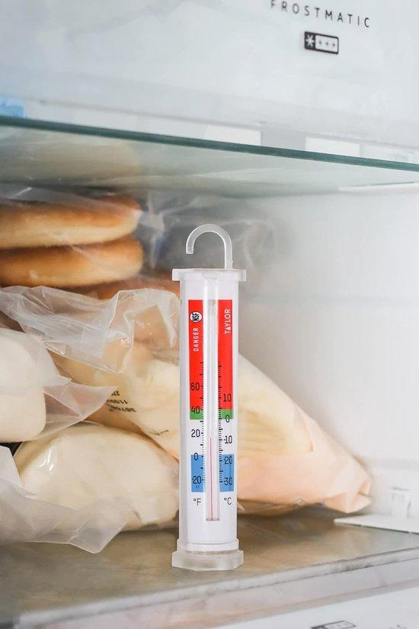
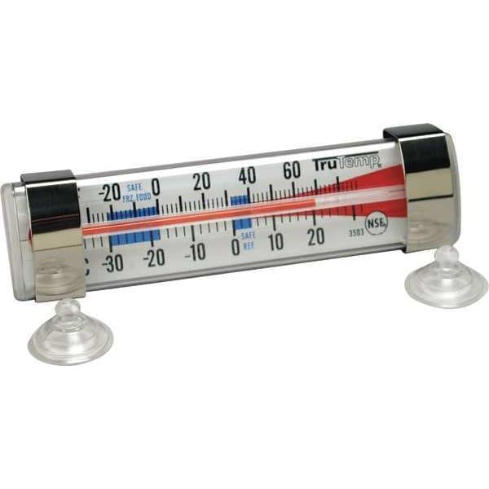
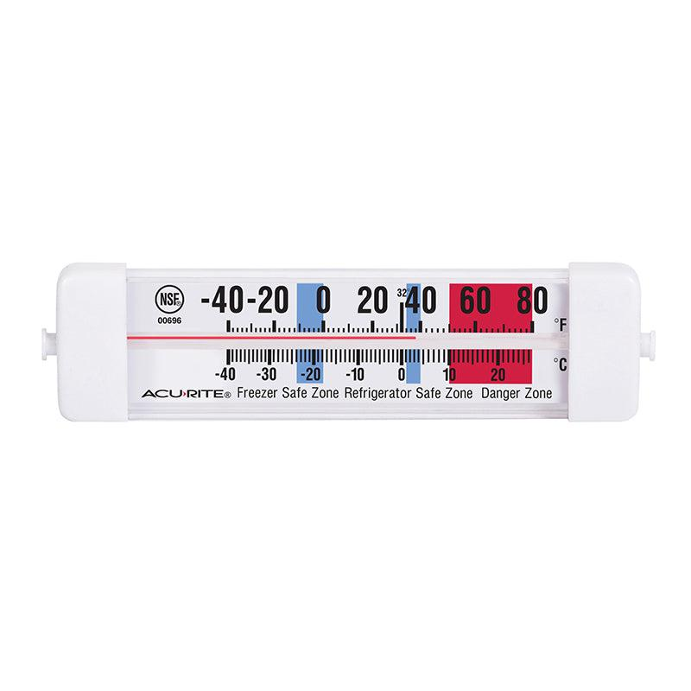
Description
Designed for monitoring cold storage temperatures.
Applications
- Refrigerators
- Freezers
- Cold rooms
- Food storage

4. Wall-Mounted Spirit Thermometer
# Source: AI Source: Provided by: [Data Path: Persons Table -> ID Column: 1, Name_En Column: Motasem Essam] -> From: [ChatGPT] on [7/17/2026]
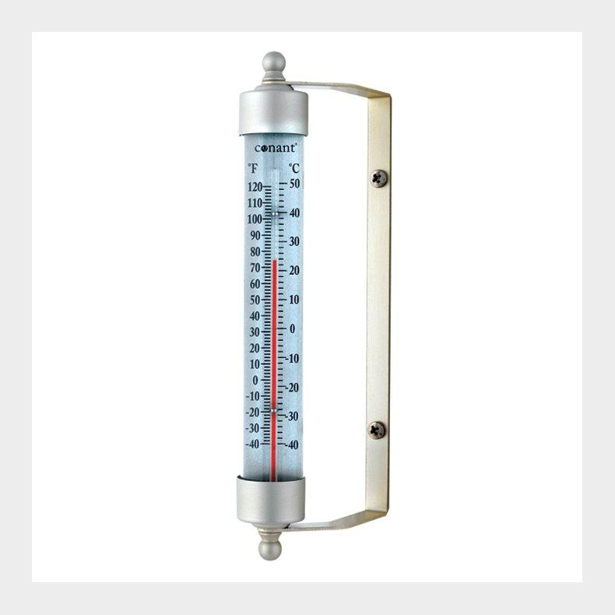
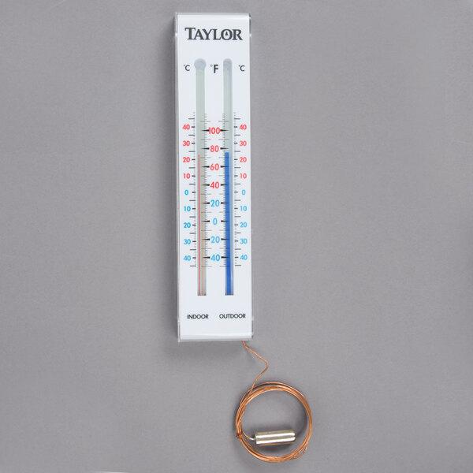
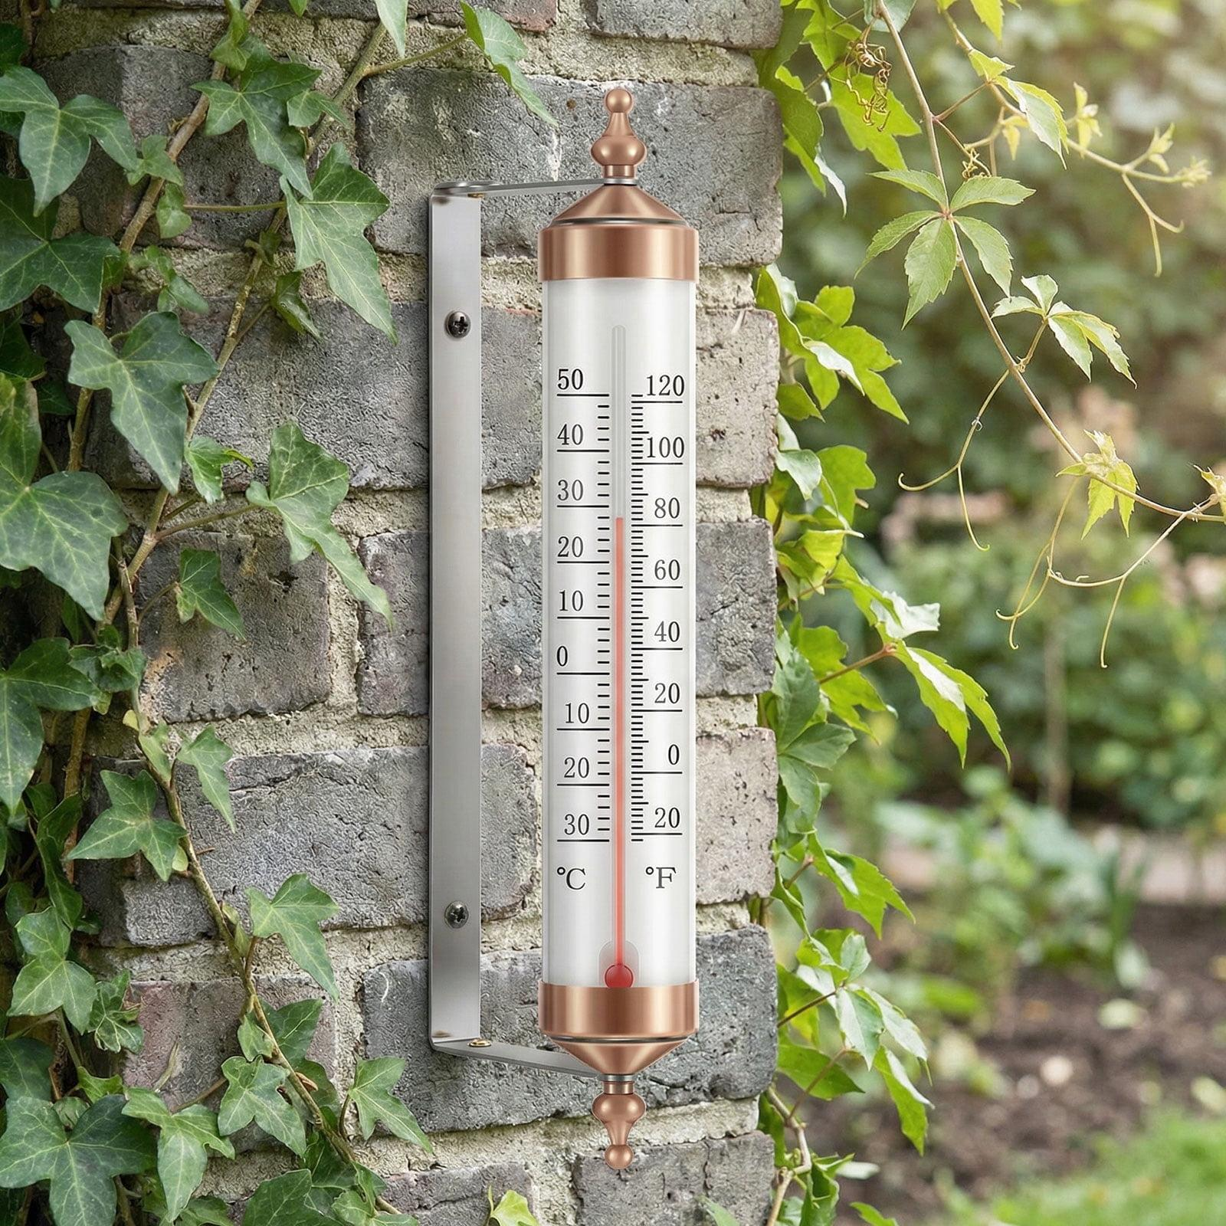
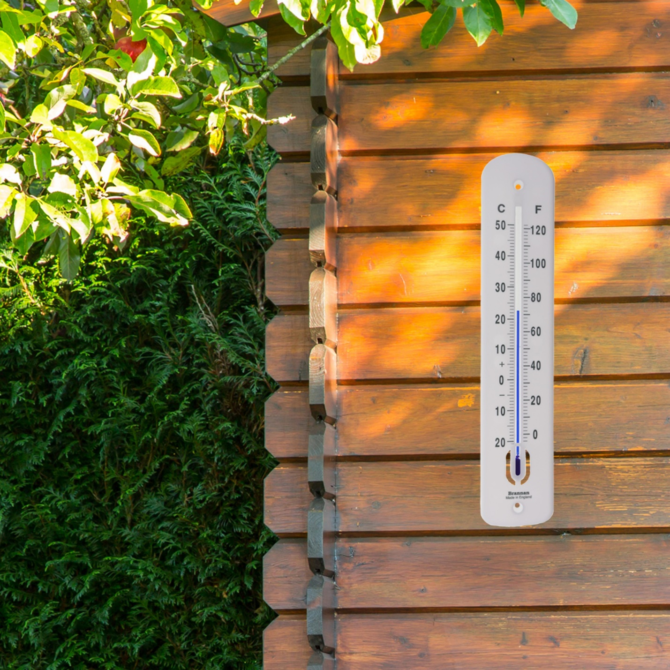
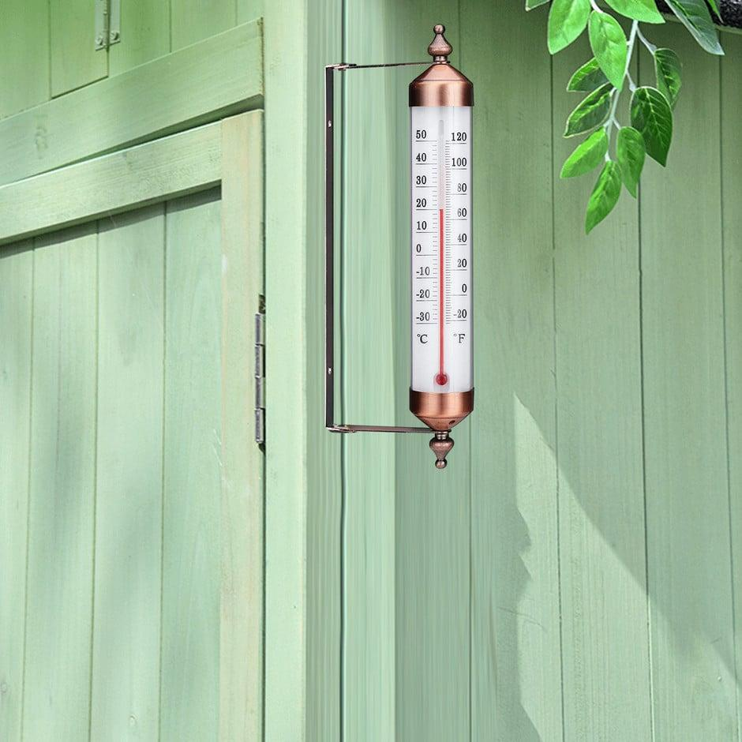
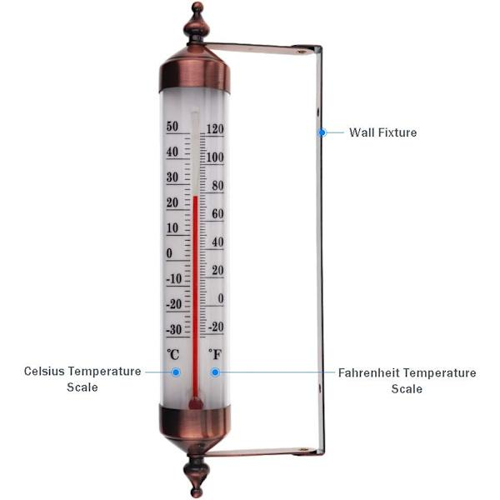
Description
Used for indoor or outdoor ambient temperature monitoring.
Applications
- Homes
- Offices
- Greenhouses
- Workshops

Common Alcohols Used
# Source: AI Source: Provided by: [Data Path: Persons Table -> ID Column: 1, Name_En Column: Motasem Essam] -> From: [ChatGPT] on [7/17/2026]
The liquid inside may be:
- Ethanol
- Toluene
- Isoamyl alcohol
- Kerosene-based colored spirits (special applications)
A red or blue dye is commonly added to improve visibility.

Measuring Units
# Source: AI Source: Provided by: [Data Path: Persons Table -> ID Column: 1, Name_En Column: Motasem Essam] -> From: [ChatGPT] on [7/17/2026]
Alcohol thermometers are commonly calibrated in:
- Degrees Celsius (°C)
- Degrees Fahrenheit (°F)
Some scientific models may also reference:
- Kelvin (K)

Measuring Range
# Source: AI Source: Provided by: [Data Path: Persons Table -> ID Column: 1, Name_En Column: Motasem Essam] -> From: [ChatGPT] on [7/17/2026]
Typical ranges:
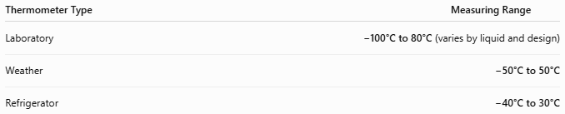
Thermometer Type | Measuring Range
Laboratory | −100°C to 80°C (varies by liquid and design)
Weather | −50°C to 50°C
Refrigerator | −40°C to 30°C
Alcohol remains liquid at temperatures much lower than mercury, making it suitable for cold environments.

Resolution
# Source: AI Source: Provided by: [Data Path: Persons Table -> ID Column: 1, Name_En Column: Motasem Essam] -> From: [ChatGPT] on [7/17/2026]
Typical resolution:
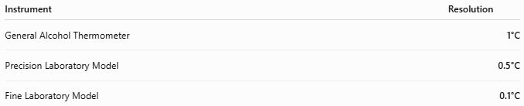
Instrument | Resolution
General Alcohol Thermometer | 1°C
Precision Laboratory Model | 0.5°C
Fine Laboratory Model | 0.1°C

Accuracy
# Source: AI Source: Provided by: [Data Path: Persons Table -> ID Column: 1, Name_En Column: Motasem Essam] -> From: [ChatGPT] on [7/17/2026]
Typical accuracy:
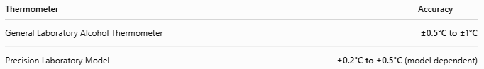
Thermometer | Accuracy
General Laboratory Alcohol Thermometer | ±0.5°C to ±1°C
Precision Laboratory Model | ±0.2°C to ±0.5°C (model dependent)

How to Use an Alcohol Thermometer
# Source: AI Source: Provided by: [Data Path: Persons Table -> ID Column: 1, Name_En Column: Motasem Essam] -> From: [ChatGPT] on [7/17/2026]
- Place the bulb in contact with the substance or environment being measured.
- Wait until the liquid column stabilizes.
- Hold the thermometer vertically.
- Read the top of the colored alcohol column at eye level.
- Record the temperature.

Example
# Source: AI Source: Provided by: [Data Path: Persons Table -> ID Column: 1, Name_En Column: Motasem Essam] -> From: [ChatGPT] on [7/17/2026]
The alcohol column aligns with:
18°C
Measured temperature:
18°C

Applications
# Source: AI Source: Provided by: [Data Path: Persons Table -> ID Column: 1, Name_En Column: Motasem Essam] -> From: [ChatGPT] on [7/17/2026]
Alcohol thermometers are used in:
- Weather stations
- Schools
- Scientific laboratories
- Environmental monitoring
- Refrigeration systems
- Greenhouses
- Aquariums
- Food storage
- Agricultural monitoring

Advantages
# Source: AI Source: Provided by: [Data Path: Persons Table -> ID Column: 1, Name_En Column: Motasem Essam] -> From: [ChatGPT] on [7/17/2026]
An alcohol thermometer:
- Is safer than a mercury thermometer because it contains no toxic mercury.
- Can measure much lower temperatures.
- Is inexpensive.
- Is easy to read due to colored liquid.
- Requires no batteries.
- Is environmentally safer if broken.

Limitations
# Source: AI Source: Provided by: [Data Path: Persons Table -> ID Column: 1, Name_En Column: Motasem Essam] -> From: [ChatGPT] on [7/17/2026]
An alcohol thermometer:
- Is generally less accurate than a high-quality mercury thermometer.
- Cannot measure extremely high temperatures because alcohol boils at relatively low temperatures.
- The liquid column may be harder to read than mercury in some lighting conditions.
- Glass construction makes it breakable.

Sources of Error
# Source: AI Source: Provided by: [Data Path: Persons Table -> ID Column: 1, Name_En Column: Motasem Essam] -> From: [ChatGPT] on [7/17/2026]
Instrument Errors
- Calibration drift
- Damaged glass
- Separated alcohol column

User Errors
- Reading from above or below eye level (parallax)
- Not allowing sufficient stabilization time
- Holding the bulb instead of the stem during measurement

Environmental Errors
- Direct sunlight during ambient measurements
- Heat transfer from the user's hand
- Rapid temperature fluctuations

Comparison with Other Temperature Measuring Instruments
# Source: AI Source: Provided by: [Data Path: Persons Table -> ID Column: 1, Name_En Column: Motasem Essam] -> From: [ChatGPT] on [7/17/2026]
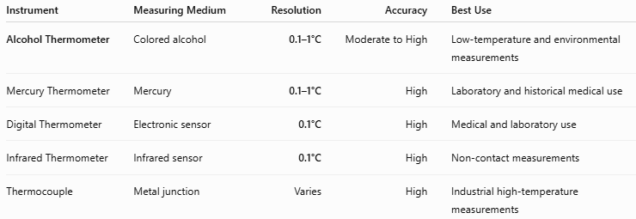
Instrument | Measuring Medium | Resolution | Accuracy | Best Use
Alcohol Thermometer | Colored alcohol | 0.1–1°C | Moderate to High | Low-temperature and environmental measurements
Mercury Thermometer | Mercury | 0.1–1°C | High | Laboratory and historical medical use
Digital Thermometer | Electronic sensor | 0.1°C | High | Medical and laboratory use
Infrared Thermometer | Infrared sensor | 0.1°C | High | Non-contact measurements
Thermocouple | Metal junction | Varies | High | Industrial high-temperature measurements

Care and Maintenance
# Source: AI Source: Provided by: [Data Path: Persons Table -> ID Column: 1, Name_En Column: Motasem Essam] -> From: [ChatGPT] on [7/17/2026]
To maintain accuracy:
- Store in a protective case.
- Avoid dropping the thermometer.
- Keep the glass clean.
- Do not expose it to temperatures beyond its specified range.
- Inspect for cracks before use.

Common Mistakes
# Source: AI Source: Provided by: [Data Path: Persons Table -> ID Column: 1, Name_En Column: Motasem Essam] -> From: [ChatGPT] on [7/17/2026]
- Reading from the wrong angle.
- Measuring in direct sunlight when ambient air temperature is required.
- Not waiting for the liquid column to stabilize.
- Using the thermometer outside its specified temperature range.
- Confusing the colored alcohol level with reflections inside the glass.

Key Points
# Source: AI Source: Provided by: [Data Path: Persons Table -> ID Column: 1, Name_En Column: Motasem Essam] -> From: [ChatGPT] on [7/17/2026]
- An Alcohol Thermometer measures temperature using the thermal expansion of colored alcohol.
- Common types:
  - Laboratory Alcohol Thermometer
  - Weather Alcohol Thermometer
  - Refrigerator/Freezer Alcohol Thermometer
  - Wall-Mounted Spirit Thermometer
- Common units:
  - °C
  - °F
- It is especially useful for low-temperature measurements, where mercury thermometers cannot operate effectively.
- It is safer and more environmentally friendly than a mercury thermometer because it contains no toxic mercury.

Conclusion
# Source: AI Source: Provided by: [Data Path: Persons Table -> ID Column: 1, Name_En Column: Motasem Essam] -> From: [ChatGPT] on [7/17/2026]
An Alcohol Thermometer is a reliable and widely used temperature-measuring instrument that operates by the expansion and contraction of colored alcohol within a sealed glass tube. Its ability to measure very low temperatures, combined with its safety, low cost, and ease of use, makes it an excellent choice for meteorology, education, environmental monitoring, refrigeration, and general laboratory work. Although it is less suitable for very high temperatures than mercury or electronic sensors, it remains one of the safest and most practical liquid-in-glass thermometers available.

